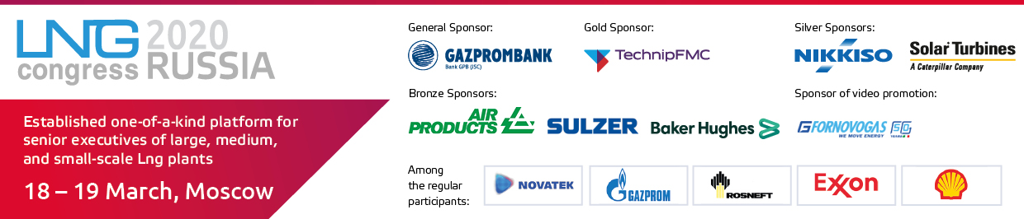

Established one-of-a-kind platform for senior executives of large, medium, and small-scale Lng plants.

Event: 7th Annual International LNG Congress Russia
Date: 18-19 March 2020
Venue: Moscow, Baltschug Kempinski
Organiser: Vostock Capital

LNG Congress Russia is an international platform which traditionally gathers LNG industry leaders from all over the globe. The event welcomes over 300 operators of large-, mid-, and small-scale LNG projects (Rosneft, Gazprom LNG Saint Petersburg, Gazprom Transgaz Yekaterinburg, Gazprom Gas Motor Fuel, Sibir-Energo, Dalgazresurs, TopGaz, and others), government, and engineering leaders of the LNG industry.
Among the speakers and panellists 2019:
- Alexander Popov, Vice President, Exxon Neftegaz Ltd.
- Stuart Bradford, Senior Deal Lead, Shell
- Sander Stegenga, Shell Technical Director for LNG Projects, Russia, Shell
- Alexey Grebenyuk, General Director, Gazprom LNG Vladivostok
- Vladimir Smelov, Oil & Gas Department, Director, Gazprombank
- Tatiana Mitrova, Director of Energy Centre, Skolkovo Energy Centre
Programme Highlights:
- 2 STRATEGIC DAYS: LARGE, MEDIUM, AND SMALL-SCALE LNG PROJECTS
- DEBATES OF INDUSTRY LEADERS! Changing global LNG market: impact of Russia on pricing mechanisms
- UPDATES FROM OPERATORS: status and news on existing and planned projects
- NEW! LNG BUNKERING: what will incentivise successful development of the industry?
- SPECIAL FOCUS: LNG as fuel – growth routes and development vectors
- IMPORTANT: RUSSIAN AND FOREIGN SOLUTIONS FOR LNG PROJECTS. Case studies
- 30+ hours of formal and informal networking. One-on-one meetings, business lunches, coffee-breaks, interactive roundtables with champagne, and a lot more
- Technology-focus presentations, road show, specialised exhibition of technology, equipment, and services from global leaders

General sponsor: Gazprombank;
Gold Sponsor: TechnipFMC;
Silver Sponsor: Nikkiso Cryo, Solar Turbines International Company;
Bronze Sponsor: Air Products, Baker Hughes, Sulzer;
Sponsor of video-promotion: FORNOVO GAS.

Event Steering Committee:
Contact: Project Producer Elvira Sakhabutdinova
E-mail: ESakhabutdinova@vostockcapital.com Tel. +44 207 394 30 90 (add. 150)

